1.0 Problem Statement
Glaucoma is a leading cause of irreversible blindness worldwide, often remaining asymptomatic until severe vision loss occurs. Early detection via retinal fundus imaging is critical to halting disease progression. However, manual screening is highly subjective, time-consuming, and prone to human error—particularly in edge cases or low-quality scans.
While deep learning models have shown promise in automating Glaucoma Optic Neuropathy (GON) detection, they are frequently criticized as "black boxes." Clinicians hesitate to trust AI models that provide a binary diagnosis without explaining the underlying anatomical reasoning. The objective of this project is to develop a lightweight, highly accurate, and fully explainable AI diagnostic dashboard that not only predicts GON but visually and linguistically justifies its reasoning to the attending clinician.

2.0 Dataset Justification & Management
The model utilizes a specialized clinical dataset containing retinal fundus images categorized into two classes: Normal (GON-) and Glaucoma (GON+). To ensure the model meets rigorous clinical standards, several advanced data management techniques were implemented. First, to prevent patient data leakage—a common issue where traditional random splitting places a single patient's multiple scans (e.g., left and right eye) across both training and validation sets, leading to falsely inflated accuracy—we implemented GroupShuffleSplit on the Patient ID column. This guarantees strict patient-level isolation between the 80% training and 20% validation splits. Additionally, because fundus scans vary wildly in illumination and clarity, we applied quality-aware weighting. Using the dataset's Quality Score parameter, we engineered a custom HYGDDataset class that scales the loss function based on image quality (Quality Score / 10.0). This approach forces the model to heavily penalize mistakes on clear, textbook images while remaining more forgiving of artifacts in blurry scans.

3.0 ML/DL Methodology
The architecture was carefully selected to balance high diagnostic accuracy with the computational efficiency required for a web-based dashboard. Specifically, we utilized EfficientNet-B0, upgrading from older, heavier models like ResNet50. Because EfficientNet uses a compound scaling algorithm that perfectly balances network depth, width, and resolution, it operates with only ~5.3 million parameters compared to ResNet50's ~25 million. This massive reduction significantly lowers inference latency and memory overhead without sacrificing diagnostic accuracy. To accelerate convergence, the model leveraged transfer learning by initializing with pre-trained ImageNet weights, while the final classification head was replaced with a fully connected linear layer outputting to our two target classes (GON- and GON+). The network was then trained using the Adam Optimizer with a conservative learning rate of $1 \times 10^-4 to preserve the pre-trained feature extractors, minimizing Cross-Entropy Loss over 10 epochs with a batch size of 16. Finally, to ensure robust generalization and prevent overfitting, the training loop continuously tracked validation accuracy and utilized a deep copy mechanism to save only the model state (.pth) from the exact epoch that achieved the absolute highest validation performance.

4.0 Preprocessing Steps
In this project, data preprocessing was performed to prepare retinal fundus images for glaucoma detection using a deep learning model. First, the dataset was loaded and organized into their respective classes to ensure proper labeling. Any unreadable or irrelevant images were removed to maintain the quality and consistency of the dataset.
Next, all images were resized into a fixed dimension to ensure uniformity when being fed into the model. This step is important as deep learning models require consistent input sizes and it also helps reduce computational complexity. The pixel values of the images were then normalized to a standard range, which improves training stability and allows the model to learn more effectively.
In addition, there is image enhancement during live inference on the dashboard, provided with interactive Brightness and Contrast sliders via PIL.ImageEnhance. This allows users to manually adjust dark or washed-out images to reveal hidden vascular structures before passing the tensor to the AI.
Finally, the dataset was split into training and testing sets to evaluate the performance of the model. Overall, these preprocessing steps ensured that the dataset was clean, standardized, and suitable for developing an accurate glaucoma detection system.

5.0 Results & Performance
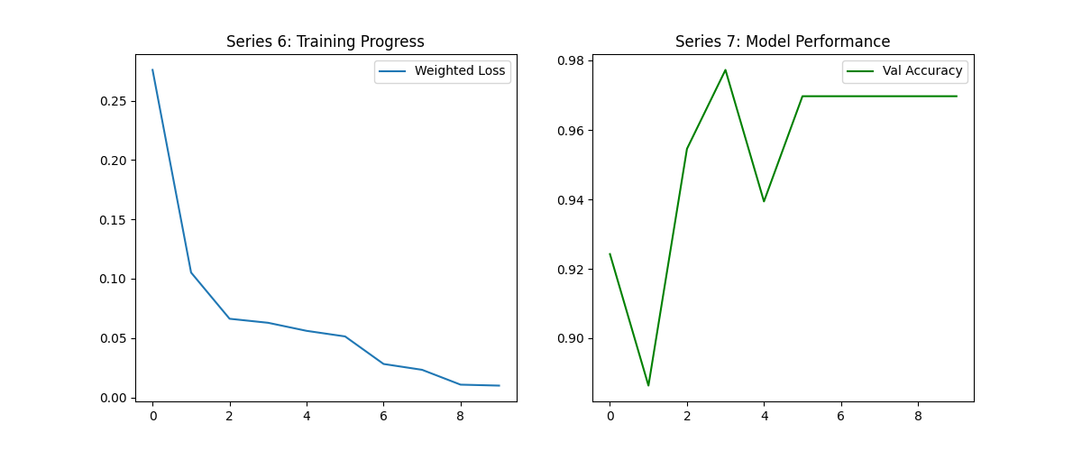
Figure 1: Training result

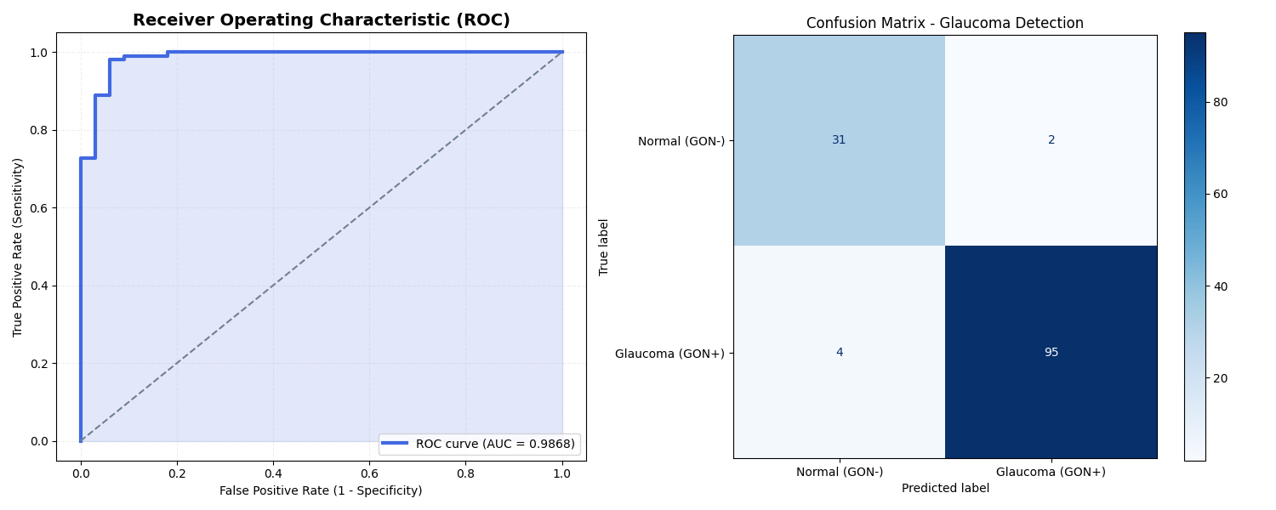
Figure 2: Evaluation result
The model was evaluated on an isolated test set of 132 unseen fundus scans using a PyTorch DataLoader for efficient batch processing. Overall, the EfficientNet-B0 architecture achieved an impressive accuracy of 95.5% (126 correct predictions out of 132). Detailed analysis of the resulting confusion matrix revealed a highly clinical Sensitivity (True Positive Rate for Glaucoma) of 96.0% alongside a Specificity of 93.9%, demonstrating a strong clinical balance in correctly identifying diseased eyes without heavily skewing toward false positives. Furthermore, the model achieved an exceptional Receiver Operating Characteristic (ROC) Area Under the Curve (AUC) of 0.9868, underscoring its robust discriminatory power across all confidence thresholds. Finally, an analysis of the training history confirmed highly stable convergence. Both training and validation loss decreased in tandem during the training loop, with validation accuracy peaking at approximately 97.5% at epoch 3. Because the training pipeline utilized automated model checkpointing, the system successfully captured and saved the neural network's weights at this exact peak, entirely avoiding late-stage overfitting and ensuring robust generalization to new patient data.

6.0 Interpretability
Probability | Interpretation
0.95 | Very confident glaucoma
0.70 | Moderate confidence
0.52 | Uncertain prediction
Below 0.52 | Low probability of glaucoma
Table 1: Tiered Confidence Threshold
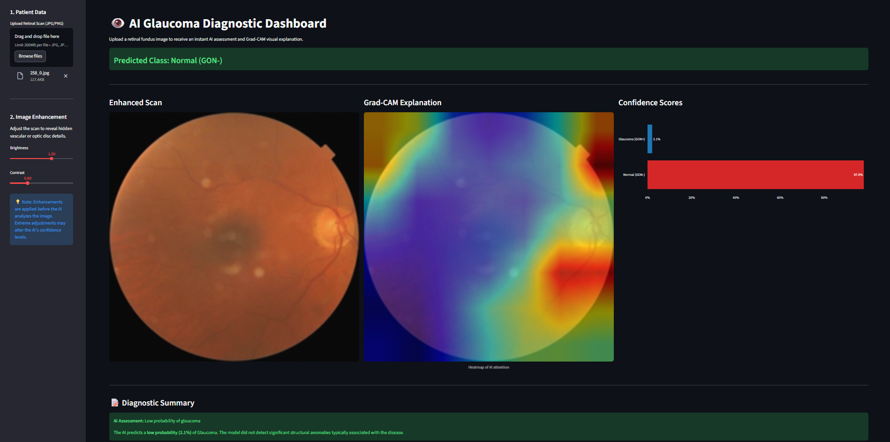
Figure 3: Dashboard using streamlit

To solve the "black box" problem inherent in deep learning, the system incorporates two distinct layers of explainable AI to ensure the model acts as a transparent, assistive diagnostic co-pilot. First, it utilizes Tiered Confidence Thresholding, moving beyond a standard binary 50% cutoff to interpret probabilities into strict clinical operating points—ranging from Low Probability to Very Confident—which automatically flags ambiguous scans for human review. Second, the system employs visual explainability via Gradient-weighted Class Activation Mapping (Grad-CAM), extracting gradients from EfficientNet's final convolutional layer to project a heatmap overlay onto the original scan. This dual-layered approach was validated against diverse clinical scenarios, demonstrating exceptional alignment between the AI’s mathematical confidence and its visual focus. To validate this explainability, the dashboard was tested against diverse clinical scenarios, demonstrating exceptional alignment between the AI’s mathematical confidence and its visual focus:
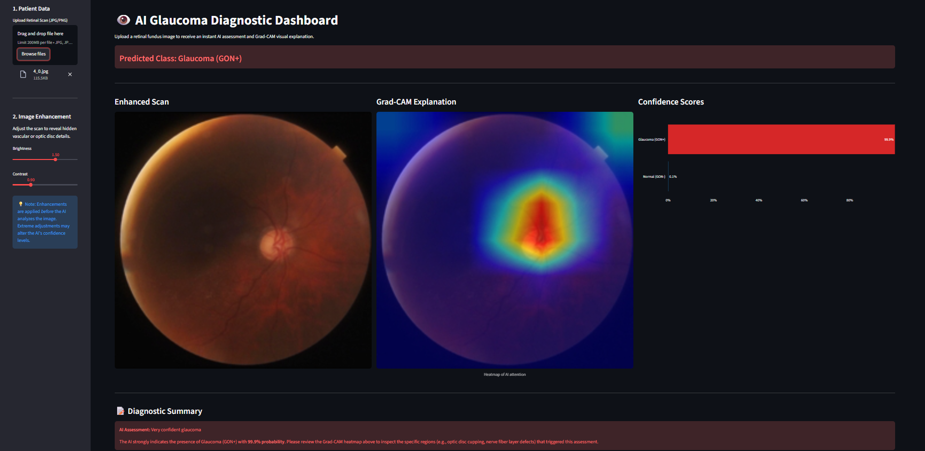
This dashboard presents a "Very Confident" Glaucoma (GON+) diagnosis, with the AI assigning an overwhelming 99.9% probability to the presence of the disease. The Grad-CAM explanation panel provides striking visual validation for this high confidence score: the intense red and yellow heatmap is perfectly centered directly over the optic disc. This concentrated focal point proves that the model is not relying on background noise or image artifacts; rather, it is accurately localizing and analyzing the exact anatomical structure where glaucomatous damage—such as severe optic nerve cupping—occurs. Even with manual brightness and contrast enhancements applied to the scan, the AI's attention remains solidly locked onto the correct clinical region, offering the attending clinician highly transparent and reliable evidence to support a positive diagnosis.

7.0 Clinical Impact & Deployment
The model is packaged into an interactive, end-to-end clinical dashboard built with Streamlit.
By integrating uploading, image enhancement, prediction, Grad-CAM visualization, and automated text summarization into a single UI, the tool is designed to act as an assistive diagnostic co-pilot. It does not replace the ophthalmologist; instead, it triages patients, builds clinical trust by "showing its work" via heatmaps, and automatically flags "Uncertain" cases that require a specialist's immediate attention. This pipeline represents a scalable, low-latency, and highly transparent approach to AI-assisted Glaucoma screening.

